# Assessment 2: Exploring agile software process project

## Purpose

Main purpose of this assessment is to experience agile and to learn writing clean code (code smells/design patterns).

|  |  |  |  |  |  |  |
| --- | --- | --- | --- | --- | --- | --- |
|  | Week 7 | Week 8 | Week 9 | Week 10 | Week 11 |  |
| Distribution Marks % Per Week | 20% | 20% | 20% | 20% | 20% | Total: 100% for Marks:30 |

To achieve this we are going to develop/refactor the application using agile process of 5 iterations.  
Starting from week 7, we are going to do 5 iterations of development.

Marks are allocated for each iteration [5 iterations * 20 = 100 marks]

Agile Project Information

**Product**: A group project of individual tasks - refactoring patterns

**Product Owner**: Lecturer

**Sprint Cycle**: Weekly [week7,8,9,10,11 - 5 iterations*]

**Regular meetings/Standup**: During [week 7,8,9,10,11] Lecture/Tutorial, each team will have 20 minutes to discuss/prioritise/clarify/select the items for TODO to be completed before next week iteration.

### Each student must provide

* What did you accomplish since the last meeting?
* What are you going to work until the next meeting?
* Any blockers/ issues in successfully completing your work?

### Marks

Each week (week 6,7,8,9,10) values @20 marks of two 10 mark sections

1. **SectionA: group mark @Weekly 10 Marks**

* Identifying/Creating log items of work
* Meeting discussion
* Client satisfaction
* Effective communication/co-ordination with team
* Group participation and following agile process

1. **SectionB: Individual contribution / marks** **@Weekly 10 Marks**

* What are you working on until the next meeting?
* What is getting in your way or keeping you from doing your job?
* What did you accomplish since the last meeting?

### Weekly Marks Allocation:

* Week 7: 20 %
* Week 8: 20 %
* Week 9: 20 %
* Week 10: 20 %
* Week 11: 20%

Total: 30 marks

### Example Task:

Task1: Re-engineer/refactor the account – billing section of the application using abstract pattern

Note: Main purpose of this assessment is to experience agile and to learn writing clean code (code smells/design patterns)

## Preparation

{X} is your group Name [A,B,C,D,E]

* Create GIT repository
  + Naming Convention: S120-PRT583-Group-{X}
  + Add all your team members
  + Add your lecture UserId: nvellela
* Create Trello Project
  + Naming Convention: S120-PRT583-Group-{X}
  + Add all your team members
  + Add your lecture UserName: narendravellela2
  + Stages
    - Product Backlog
    - Sprint Backlog
    - In-Progress
    - In-Testing
    - Ready For Review
    - Production
* Every Team Member
  + Confirm that you can access GIT Repo
  + Confirm that you can access Trello
    - GIT- Create a Folder Naming Convention: S12345-LastName FirstName
    - GIT- Create 5 sub-folders
      * Naming Convention: Sprint-{1 to 5}-Deliverables
      * In each sprint folder create a readMe.txt file with trello link and push your changes
    - Create Tasks in Trello – Product Backlog
      * Create minimum 15 tasks individually in the similar format as below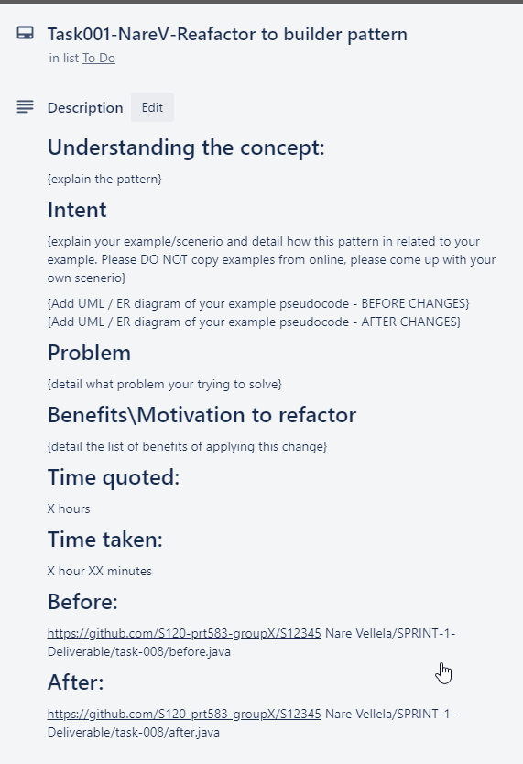
      * Note: Please leave the Description field details as above when creating.

As part of grooming process for each iteration, we prepare and fill the tasks details and progress the tasks and update as you implement the task

## Weekly Activities:

Sprint Planning Meeting:

* Where: ONLINE COLLABORATION
* When: Every Friday starting from WEEK-7
* Attendee(s): All Group members
* Discussion Topics:
  + Task Status that are committed last iteration
  + Tasks allocation for next iteration
  + Any issues
  + Team co-ordination and Agile practices

|  |  |
| --- | --- |
| Group A | 1:00PM |
| Group B | 1:20PM |
| Group C | 1:40PM |
| Group D | 2:00PM |
| Group E | 2:20PM |

## Final Submission

Each group has to submit one page report to LearnLine with the following

* URL’s
* Team members info
* List lessons learn
* Feedback

## Rubric

|  |  |  |  |
| --- | --- | --- | --- |
| **Weekly allocation (20%)** | Level-1(0-10%) | Level-2(10-15%) | Level-3(15-20%) |
| Knowledge | Shows limited understanding of agile process | Shows considerable understanding of agile concepts | Shows high degree of understanding of agile concepts |
| Planning | Student demonstrates limited preplanning | Student demonstrates considerable preplanning | Student demonstrates thorough preplanning |
| Documentation | Missing or unclear details on task.  Missing or incomplete analysis on risk assessment.  Missing or incomplete test analysis. | Complete details on task.  Complete analysis on risk assessment.  Complete test analysis. | Detailed description on task.  Detailed analysis on risk assessment.  Detailed test analysis. |
| Application Implementation | Student creates incomplete and limited functionality | Student implemented the assigned tasks | Student implemented assigned tasks with effectiveness and extended ideas |
| Communication | Student  Communication /co-ordination with team with limited effectiveness. | Student  Communication /co-ordination with team with considerable effectiveness. | Student  Communication /co-ordination with team with high degree of effectiveness. |